Software Design Specification

For

Language Learners United over 9000

Michael Cottrell

Riley Tucker

Project Description:

The purpose of this system is to help people learn languages, about the people, culture, and countries that speak the languages of interest, and to be able to communicate with and help other language learners.

Project functions:

The major functions are as follows: A flash card game for the language of the user’s choice in which they can learn top words of a language. Ability for the user to find and message users to help facilitate learning. Ability for the user to see facts about the language of the user’s choice and countries, cultures, or the people who speak the language of choice.

**Table of Contents**

1 Data Design 3

1.1 Database ERD 3

2 System Feature to ERD Explanation. 4

2.1 Flash Card Game (SRS System Feature 4.1) 4

2.2 Cultural Information (SRS System Feature 4.2) 4

2.3 Messaging Users (SRS System Feature 4.3) 4

3 User Interface Design 5

3.1 Site Map 5

3.2 Application Interface 6

3.2.1 Login Page 6

3.2.2 Main Menu 6

3.2.3 Flash Card Games (SRS System Feature 4.1) 7

3.2.4 Facts Screen (SRS System Feature 4.2) 7

3.2.5 Search Users (SRS System Feature 4.3) 8

3.2.6 Messages (SRS System Feature 4.3) 8

3.2.7 Message User (SRS System Feature 4.3) 9

4 Test Plan 10

Test Case 1: Flash Card Game 10

Test Case 2: Wikipedia page 11

Test Case 3: Messaging and Finding Users 11

# 1 Data Design

## 1.1 Database ERD

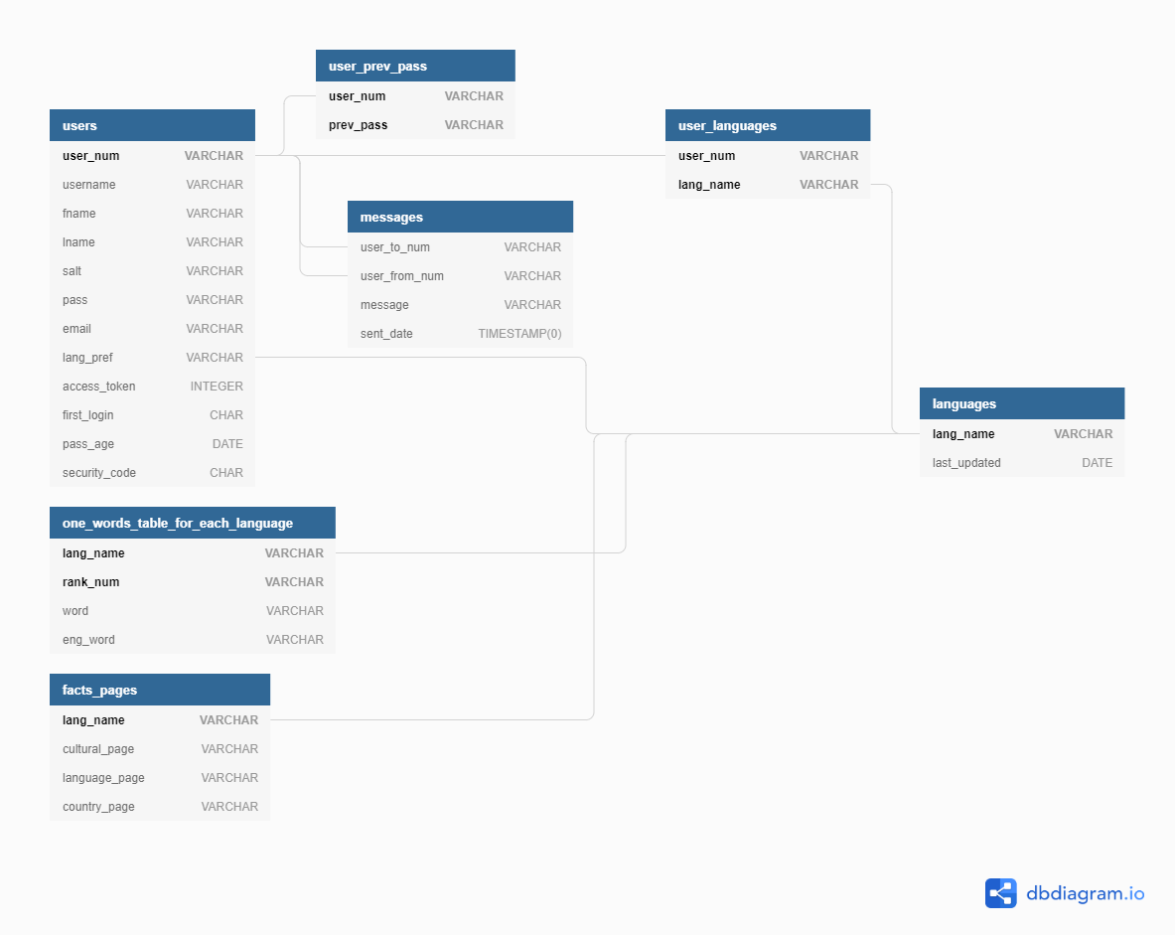

# 2 System Feature to ERD Explanation.

## 2.1 Flash Card Game (SRS System Feature 4.1)

* + 1. User table allows for user to login and have persistent data and keep track of what language the user prefers. This allows the flash card game to default to the user preference.
    2. The language table allows for the website to know which languages are available. It also helps the database find the words tables for each language to populate flash cards.

## 2.2 Cultural Information (SRS System Feature 4.2)

* + 1. Facts links table allows the website to use URLs contained to grab current WIKI data for each different type of fact the user wants. It then displays to the facts view depending on which type of fact the user wanted.

## 2.3 Messaging Users (SRS System Feature 4.3)

* + 1. User table allows for storing of persistent user list. This allows for users to be queried with a preference for the language the user wants to learn and what language the other users are proficient in by matching it to the user_languages table.
    2. Once the user selects another user to message and sends a message the message will be stored in the messages table for persistent storage of messages.
    3. These messages will be deleted after 30 days to decrease storage concerns.

# 3 User Interface Design

## 3.1 Site Map

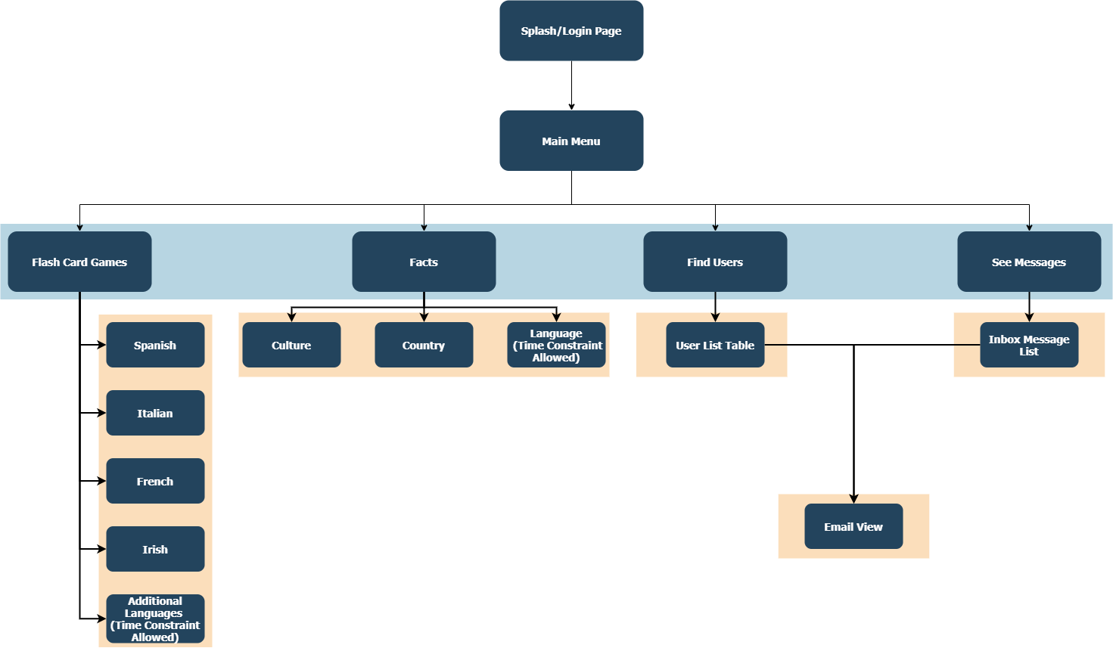

## 3.2 Application Interface

### 3.2.1 Login Page

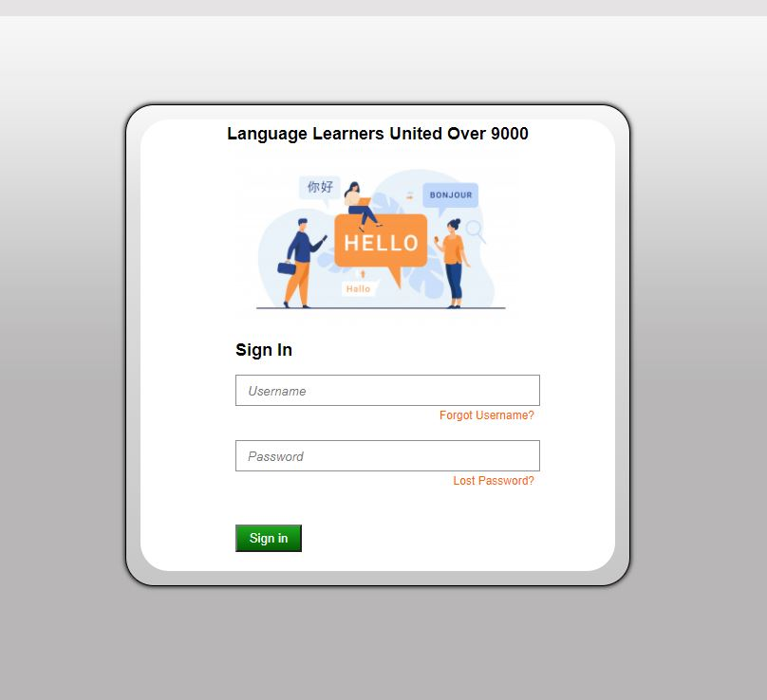

### 3.2.2 Main Menu

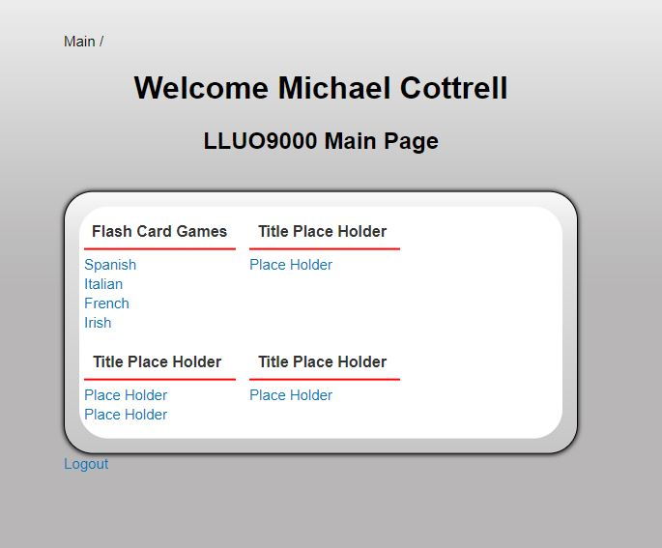

### 3.2.3 Flash Card Games (SRS System Feature 4.1)

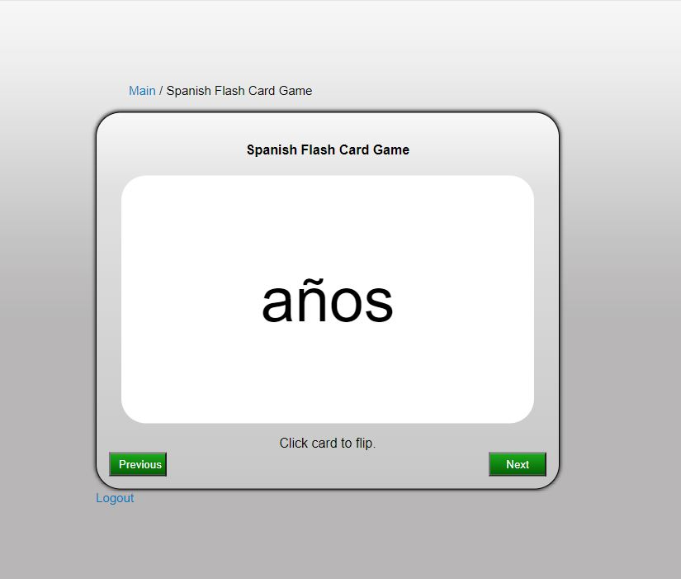

### 3.2.4 Facts Screen (SRS System Feature 4.2)

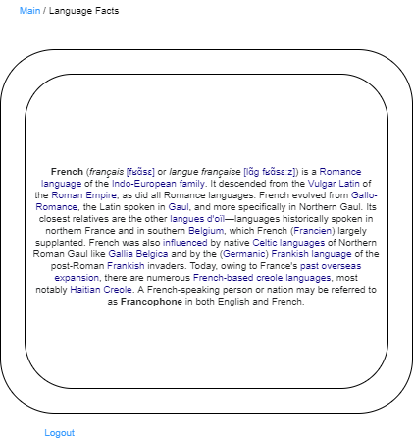

### 3.2.5 Search Users (SRS System Feature 4.3)

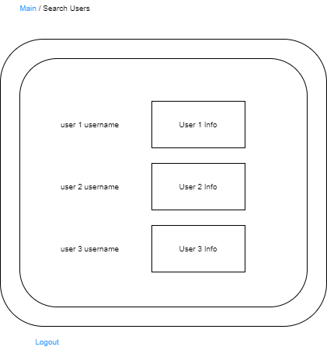

### 3.2.6 Messages (SRS System Feature 4.3)

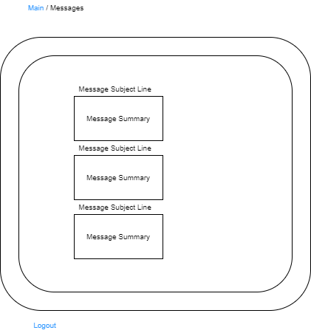

### 3.2.7 Message User (SRS System Feature 4.3)

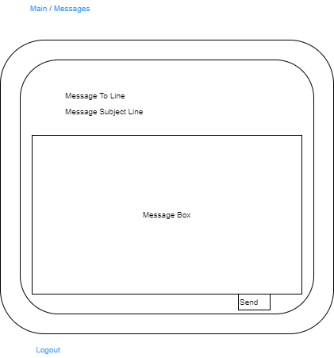

# 4 Test Plan

|  |  |  |  |  |  |  |  |
| --- | --- | --- | --- | --- | --- | --- | --- |
| **Test Cases** | **Test ID** | **Title** | **Objective** | **Setup** | **Test Data** | **Expected Result** | **Actual Result** |
| Test Case 1: Flash Card Game | 1.1 | See words | show words for a certain language on the view. | card in middle, next word, and previous buttons underneath. | 10 words from Italian. | Click on the word to swap to the English translation and click again to swap to the Italian word. | Card game correctly swapped between the Italian word and its translation. |
|  | 1.2 | Next word | Cycle to the next word in the list of available words | card in middle, next word and previous buttons underneath. | 10 words from Italian | Click on the next button to cycle forwards through words not yet seen by the user to see another word.  Add words to words_seen array so that user can keep going through words with seemingly no limit. | Card game correctly swapped between 10 Italian words and test 1.1 succeeded on each word. It kept cycling through words as if there was no limit. |
|  | 1.3 | Prev word | Cycle to the prev word in the list of seen words | card in middle, next word and previous buttons underneath. | 10 words from Italian | Click on the prev button to cycle backwards through words seen by the user to see previous words. Add words to words_seen array so that the user can see all previous seen words again. | Card game successfully transitioned backwards through previously seen words and their translations. |
| Test Case 2: Wikipedia page | 2.1 | See dummy data on culture page | Show dummy data on culture screen | Country and language followed by dummy data in view | Mock culture data | Click link to get to the culture page  See dummy data on culture view |  |
|  | 2.2 | Pull data from Wikipedia | To pull data from Wikipedia to be used in culture function | Object that has all relevant information of the culture selected | Actual data pulled from Wikipedia | Use API to get json data from Wikipedia  Temp object to hold json data to see if it’s being done correctly  See correct data in the json object |  |
|  | 2.3 | Wiki data on Culture page | To show correct Wiki data on Culture Page | Country and language followed by data from Wikipedia in view | Data pulled from Wikipedia | Use API to pull data from wiki  Show data on page view for culture  Show correct wiki data on culture page |  |
| Test Case 3: Messaging and Finding Users | 3.1 | Search Users | See other users on the site to pick one to talk to | Table list of users and links to message them. | 3 default users | click on link to view to see other users  click on them to get information on user shown to make sure its linked to the correct profile |  |
|  | 3.2 | Message user | Show view to message user and enter message into database. | Email style looking view with buttons to send and cancel | user info for both user sending and receiving | Type up email to test and send email.  See if email message shows In the database. |  |
|  | 3.3 | Receive Message | Get message from another user and show the message to current user. | Email style looking view with ability to reply | email sent from test case 3.1 | Show email and reply to email.  Send email into database |  |